**Ideation Phase**

**Define the Problem Statements**

|  |  |
| --- | --- |
| Date | 28 JUNE 2025 |
| Team ID | LTVIP2025TMID41140 |
| Project Name | Smart Sorting: Transfer Learning for Identifying Rotten Fruits and Vegetables |
| Maximum Marks | 2 Marks |

**Customer Problem Statement :**

Users often struggle to visually identify whether fruits or vegetables are still fresh or have begun to rot. This leads to unnecessary waste or potential health risks.

**How might we help users accurately identify fruit and vegetable quality using a simple, AI-powered image-based web tool?**

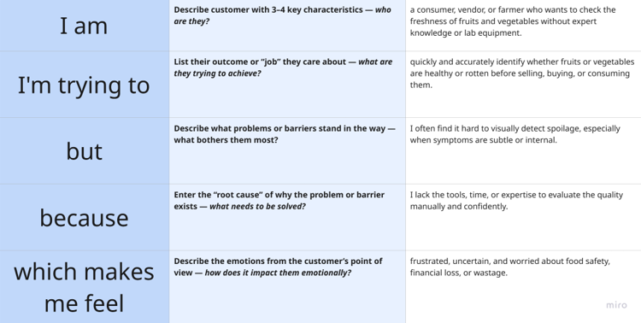

**Example:**

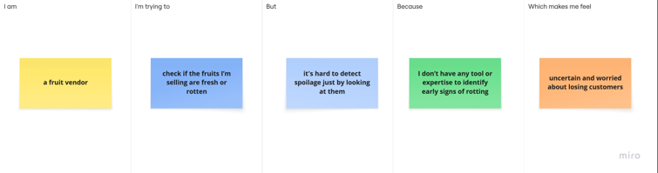

|  |  |  |  |  |  |
| --- | --- | --- | --- | --- | --- |
| **Problem Statement (PS)** | **I am (Customer)** | **I’m trying to** | **But** | **Because** | **Which makes me feel** |
| PS-1 | a supermarket staff responsible for quality checking produce | quickly check if items on shelves are still good | manual inspection takes time and isn’t always accurate | I manage hundreds of items and don’t have time to check each one carefully | overwhelmed and afraid of customer complaints or returns |
| PS-2 | an online grocery delivery startup founder | ensure only fresh produce is delivered to customers | quality issues are often discovered only after dispatch | no smart system to check images of produce before delivery | concerned about negative reviews and business reputation |